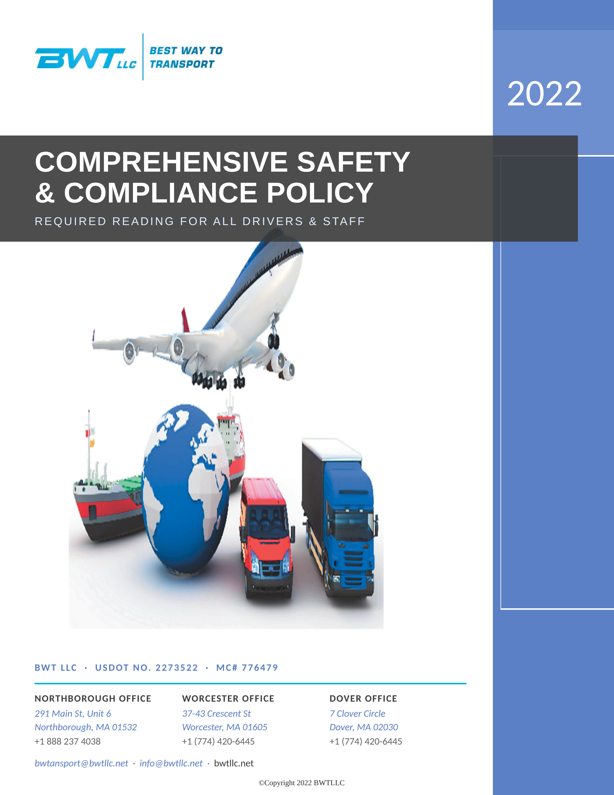

INTRODUCTION

BWT LLC is committed to the highest level of safety and compliance. The purpose of this company policy is to provide guidance to drivers and staff in complying with all the Federal Motor Carrier Safety Regulations.

All the requirements in this policy manual are mandated by the U.S. Department of Transportation and when complied with, will help the company in our efforts to achieve and maintain the lowest possible CSA safety scores and avoid the possibility of monetary penalties and, more importantly, a negative safety rating issued by the USDOT.

All drivers and staff should read this policy in its entirety and comply with the sections that are related to their position. Please do not hesitate to ask for any necessary clarifications.

BWT values every employee's contributions toward making this the safest and most successful company possible.

Sincerely,

TABLE OF CONTENTS

DRIVER QUALIFICATION REQUIREMENTS Page s
Driver Qualification File Page 5
Employment Application Page 5
Inquiry To Previous Employers Page 5
Inquiry to State Agencies Page 5
Annual Review Of Driving Record Page 6
Annual Driver's Certification of Violations Page 6
Driver's Road Test Certificate or Equivalent Page 6
Medical Examination and Certificate Page 6

VEHICLE MAINTENANCE REQUIREMENTS Page 6
Maintenance Files Page 6
Labeling the Maintenance File Page 6
Annual Periodic lnspection Page 7
Maintenance Schedule and Records Page 7
Maintenance Receipts and lnvoices Page 7
Daily Vehicle Inspection Reports (DVIRs) Page 7
Roadside Driver-Vehicle Inspections Page 7
Inspector's Certification Page 8
Brake Inspector's Certification Page 8

CONTROLLED SUBSTANCES AND

ALCOHOL TESTING REQUIREMENTS Page 8
Drugs and Alcohol Program Records Retention Page 8
Pre-employment Controlled Substance Tests Page 8
Random controlled Substance and Alcohol Tests Page 8
Post-Accident Controlled Substance and Alcohol Tests Page 8
Supervisor's Reasonable Suspicion Training Page 9
Controlled-Substance and Alcohol Policy and Educational lnformation Page 9
Biennial Reports Page 9

HOURS OF SERVICE REQUIREMENTS Page 9
Electronic Logging Devices Page 9

Compliance with Hour-of-Service Rules Page 10
Submission and Retention of Logs Page 10
Review of Logs Page 10
ELD In-Vehicle Requirements Page 10

ADDITIONAL REGULATORY REQUIREMENTS Page 11
Bi-annual Update Page 11
MCS-90 Page 11
Accident Register Page 11

DRIVER QUALIFICATION REQUIREMENTS

Driver Qualification Files
A driver qualification file will be completed by and maintained on file for every driver that operates under the company's USDOT number, whether it is a company­ employed driver or an owner-operator.

Employment Applications
Each commercial driver applicant is required to complete and sign the USDOT­ compliant employment application. Per USDOT regulations, each employment application will be retained by the company for as long as the driver is employed and for a minimum of three years after the driver's employment ends.

Inquiry To Previous Employers
Per USDOT regulations, an inquiry will be made to the previous employers of each newly hired commercial driver regarding the driver's period of employment, safety performance and compliance with the USDOT's drug and alcohol regulations.

With the driver's written permission, inquiries will be made to all previous employers that the driver had during the previous three years and all employers for which the driver held a USDOT-regulated position for the previous 10 years.

Information received in response to previous employer inquiries will be retained in the driver's qualification file. With a written request, drivers will have the opportunity to view and rebut any information received from previous employers.

The time, date, and method of contact made to each previous employer will be documented, even if there is no response from the previous employer.

Inquiry to State Agencies
A 3-year motor vehicle record (MVR) will be obtained from State driver's license agency (DLA) of the state where each driver holds his or her driver's license. This will be done at the time of hire and at a minimum of every twelve months for each commercial driver.

Annual Review of Driving Record
An annual review of the driving record of each driver will be completed and signed by the company at a minimum of every twelve months.

Annual Driver's Certification of Violations
Every 12 months, each driver must make a list all traffic violations that he or she was convicted of during the previous 12 months. The list should be certified with the driver's signature.

Driver's Road Test Certificate or Equivalent
Newly hired drivers will be road-tested by the company and a certificate of the road test will be maintained in their file. *However, if the driver holds a COL, he will not need to be road-tested if a copy of his COL is retained in his file.

Medical Examination and Certificate
Drivers should always have their DOT medical examinations updated before their medical certification card expires. Drivers should use a medical examiner that is listed on the National Registry of Certified Medical Examiners located at https://www.fmcsa.dot.gov/national-registry-certified-medical-examiners-search. Drivers should turn their new medical certification card in to the company so that it can be retained in their driver qualification file. *Per the Federal regulations, the company will verify and document that the medical examiner used by each driver is listed on the the national registry.

VEHICLE MAINTENANCE REQUIREMENTS

Maintenance Files
A vehicle maintenance file will be maintained for every vehicle that operates under the company's USDOT number, whether it is owned or leased by the company, including vehicles used by owner-operators.

Labeling the Maintenance File
Each vehicle maintenance file will be labeled with the Year, Make, Serial (VIN) Number, Company Number if used, and Tire Size of the vehicle.

Annual Periodic Inspection
No vehicle, tractor nor trailer, shall be operated with an expired Annual Periodic (Federal) Inspection. All vehicles must receive an Annual Periodic Inspection at the required interval and a copy of the inspection form must be provided to the company to be retained in the vehicle's maintenance file for 14 months.

Maintenance Schedule and Records
Each vehicle maintenance file will contain:
- A means to indicate the nature and due date of the various inspection and maintenance operations to be performed and
- A record of inspection, repairs, and maintenance indicating their date and nature.

Preventive Maintenance Schedule
All tractor-trailer units must receive Preventive Maintenance Service every 20,000 miles. The PM service must include at a minimum, an oil change, a check for oil and air leaks, and inspections of tires and wheel assemblies, the braking system, structural components, air and electrical hoses, the lighting system, wipers, and horns. All maintenance issues discovered must be repaired before the unit is dispatched again. Invoices and/or receipts for the preventive maintenance service and all maintenance and repairs on all vehicles must include an identification of the vehicle by Year, Make, and VIN number.

Maintenance Receipts and Invoices
All receipts and invoices for maintenance and inspections performed on vehicles operated under the company's USDOT number must me provided to the company to be retained in the vehicle's maintenance file. This includes leased vehicles and vehicles operated by owner-operators. Any receipts and invoices not in the possession of the company must be made available upon request.

Daily Vehicle Inspection Reports (DVIRs)
Each driver should complete a vehicle inspection on their vehicle each day. They should complete the Daily Vehicle Inspection Report (DVIR) whenever they discover a maintenance issue on their vehicle and provide the DVIR to the company.
The company should ensure that all maintenance issues listed on the DVIRs are repaired and should retain all DV/Rs for a minimum of 90 days.

Roadside Driver-Vehicle Inspections
Drivers must submit all inspections conducted by Federal and State commercial vehicle inspectors to the company as soon as possible after the inspection is completed. The company and drivers will ensure that all Out-of-Service violations are corrected or repaired before the vehicle leaves the inspection location (unless instructed to do so by a law enforcement officer) and all other violations are corrected or repaired before the vehicle is dispatched again.

Inspector's Certification
The company will keep evidence of inspector's certification on file for any person that performs the annual periodic inspections on vehicles operated under the company's USDOT number. Any Inspector's Certification that is not in the possession of the company should be made available upon request.

Brake Inspector's Certification
The company will keep evidence of brake inspector's certification on file for any person that performs brake inspections and service on vehicles operated under the company's USDOT number. Any Brake Inspector's Certification that is not in the possession of the company should be made available upon request.

CONTROLLED SUBSTANCES AND ALCOHOL TESTING REQUIREMENTS

Drugs and Alcohol Program Records Retention
All documents related to DOT controlled-substance and alcohol testing, including custody and control forms and test results will be retained by the company in accordance with the retention schedule stated in Part 382 of the Federal regulations.

Pre-employment Controlled Substance Tests
The company will ensure that it has received a negative pre-employment controlled­ substance test result for each driver before allowing the driver to operate a commercial motor vehicle. All relevant documentation will be retained.

Random controlled Substance and Alcohol Tests
All drivers will be randomly tested for controlled-substances and alcohol as required. Drivers should proceed to the specified location to be randomly tested as instructed. All relevant documentation should be provided to the company.

Post-Accident Controlled Substance and Alcohol Tests
Any driver involved in an accident will receive a post-accident controlled-substance and alcohol test when required by the Federal Motor Carrier Safety Regulations (FMCSR). Any circumstances that prevent the administration of a post-accident controlled-substance and/or alcohol test as required by the FMCSR will be documented. All relevant post-accident controlled-substance and alcohol testing documentation will be retained by the company.

Reasonable Suspicion Controlled Substance and Alcohol Tests
Any driver that exhibits the symptoms of being under the influence of controlled-substances or alcohol will be subjected to a Reasonable Suspicion controlled-substance and/or alcohol test. The supervisor that makes this determination will have previously received the reasonable suspicion training required by the FMCSR. All relevant documentation will be retained by the company.

Controlled-Substance and Alcohol Policy and Educational Information
The company's comprehensive controlled-substance and alcohol policy/educational information will be provided to all drivers. Drivers must sign for receipt of the information.

Supervisor's Reasonable Suspicion Training
Per the Federal regulations, a supervisor must receive one hour of controlled­ substance and one hour of alcohol Reasonable Suspicion training. Evidence of the "one-time" required training will be maintained by the company.

Bi-annual Reports
The company will obtain controlled-substance and alcohol testing bi-annual reports from our consortium twice a year.

HOURS OF SERVICE REQUIREMENTS

Electronic Logging Devices
The company will use an Electronic Logging Device (ELD) brand and version that is registered with the Federal Motor Carrier Safety Administration to log each driver's Hours-of-Service.

Someone on the staff will be familiar with the use of the ELD system and will be capable of retrieving the data.

All drivers will be familiar with the operation of the ELD and ensure that the ELD is used when required.

Portable ELDs will be mounted in a fixed position during the operation of the commercial motor vehicle and visible to the driver when seated in the normal driving position.

Compliance with Hour-of-Service Rules

Every driver should use electronic logs when required and should ensure that all electronic logs (and paper logs, when applicable) are complete and accurate.
Drivers should comply with all the hours-of-service regulations including the 11-hour, 14-hour, and 60/70-hour rules.

Drivers who demonstrate a lack of understanding of the hours-of-service rules will receive remedial training.

Drivers who willfully violate the hours-of-service rules will be subject to disciplinary actions.

Submission and Retention of Logs
Drivers must sign and submit their logs to the company electronically, or by hard copy when applicable, at the end of each work day. Drivers must also submit the company-designated supporting documents with the logs. (i.e. fuel receipts, toll receipts, etc.)

After reviewing the logs and supporting documents the company will retain them for a minimum of 60 days.

Per the Federal regulations, electronic logs will be retained on a device other than the ELD Unit in the vehicle.

Review of Logs
Driver's logs will be reviewed for completeness and accuracy, and to ensure that drivers are following the 11-hour, 14-hour, and the 60/70-hour rules.

Any Hours-of-Service compliance issues will be addressed with the drivers.

ELD In-Vehicle Requirements
Portable ELDs will be mounted in a fixed position during the operation
of the commercial motor vehicle and visible to the driver when the driver is seated in the normal driving position.

Per Federal regulations, Every vehicle must contain an ELD information packet at all times during operation that contains the following items:

A user's manual describing how to operate the ELD
An instruction sheet describing ELD malfunction reporting requirements and recordkeeping procedures during ELD malfunctions
A supply of blank driver's records of duty status with graph-grids sufficient to record the driver's duty status and other related information for a
minimum of 8 days.

ADDITIONAL REGULATORY REQUIREMENTS

Biennial Update
The company will update our MCS-150 Company Information every two years as required. This will be done through the FMCSA's website.

MCS-90
The company will obtain and retain on file an MCS-90 Insurance Form from our

insurance provider. We will get a new MCS-90 each time we change or update our insurance.

Accident Register
The company will maintain an accident register that contains the information on any DOT-recordable accident that any of our vehicles are involved in. A DOT-recordable accident is an accident involving a commercial motor vehicle where, regardless of who was at fault, any vehicle was towed from the scene, any person was transported for medical treatment, or anyone was fatally injured. In addition, the company will retain all police reports and other documents associated with an accident.

Safe Driving Policy
The violation of traffic laws while operating a commercial motor vehicle can lead to injuries and fatalities of the commercial vehicle driver and other members of the motoring public. In addition, multiple traffic violations by company drivers, like bad roadside inspections, causes the company's CSA safety scores to rise. High safety scores lead to compliance reviews and audits by the USDOT and State commercial enforcement agencies, high insurance rates by our insurance company, and difficulty in getting loads by shippers and brokers.

All drivers are expected, at all times, to operate all company-owned vehicles and vehicles operating under the company's authority as safely as possible. This includes operating all vehicles in accordance with the laws, ordinances and regulations of the jurisdictions in which they are being operated and operating the vehicles in such a manner that precludes citations for speeding, stop sign and traffic light violations, reckless or unsafe driving, following too closely, unsafe lane changes, failure to signal, talking on the cell phone and other distracted driving violations and all other moving violations.

Drivers who repeatedly receive citations for traffic violations (which are visible online on the DOT's website) will be subject to disciplinary actions to include temporary suspensions and possible termination.

Disciplinary Measures
Drivers who willfully violate the Federal Safety Regulations or any company safety policy pertaining to Driver Qualifications, Hours of Service, Drug and Alcohol usage or testing, safe driving, or vehicle maintenance will be subject disciplinary measures as follows:
First Offence: Verbal Counseling Second Offence: Written Reprimand Third Offence: 3 Days off without Pay Fourth Offence: Termination

Company Safety Policy Receipt Page
This company compliance policy is intended to ensure that the company is operating at the highest level of safety and compliance with the Federal Motor Carrier Safety Regulations. It should be adhered to by all drivers and staff as applicable and is subject to changes by the company's president as necessary.

President Date

Received By: _
Date

